**ASSIGNMENT # 01**

**DATABASE SYSTEM (CS-329)**

**SUBMITTED BY**

**MUNIB-UL-HASSAN**

**ROLL NO #**

**CS19-037**



**SUBMITTED TO**

**SIR ANAD**

**DEPARTMENT OF COMPUTER SCIENCE**

**SIR SYED UNIVERSITY OF ENGINEERING AND TECHNIOLOGY**

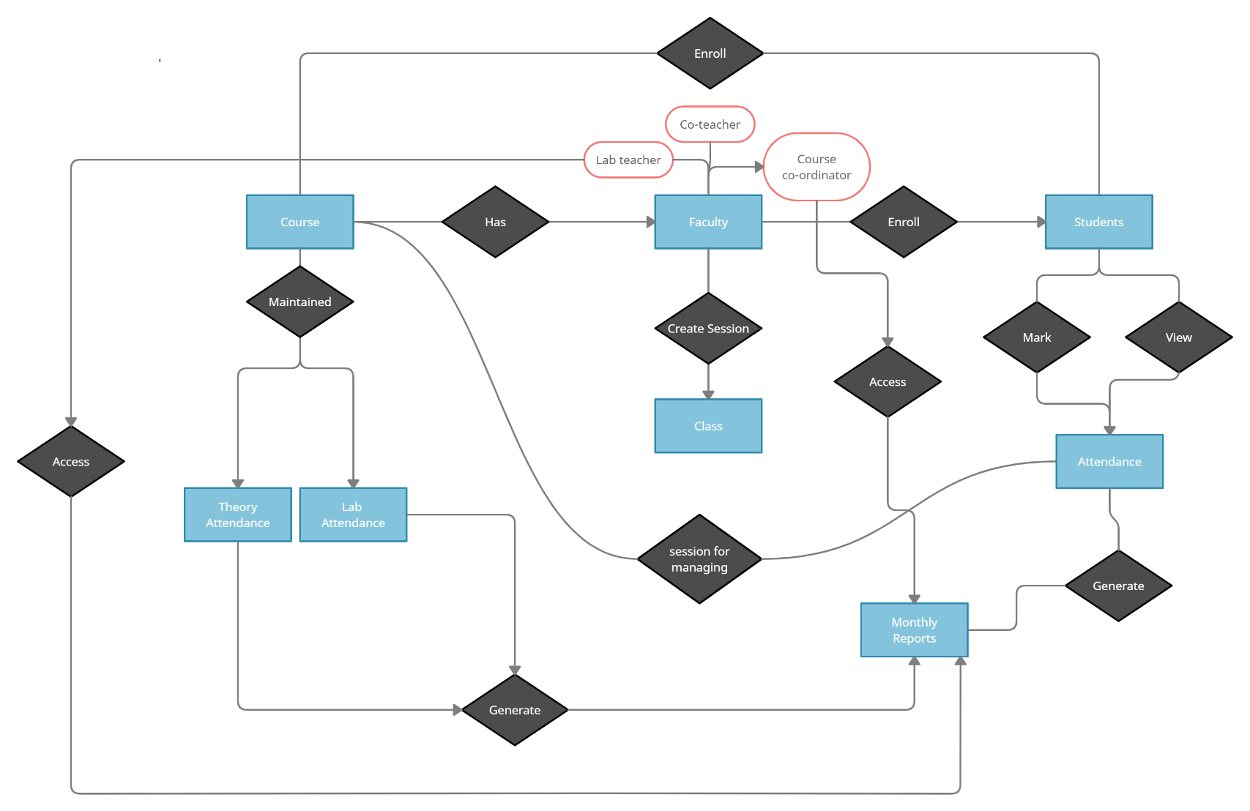QNO 01: